Michael Rumley (150251891)

CSC1021 Project 1- Student Marks Table

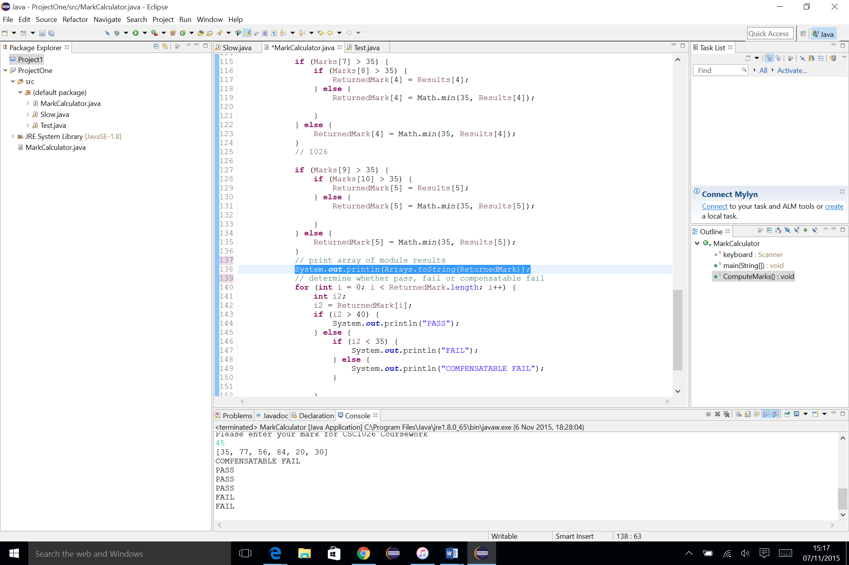**Testing**

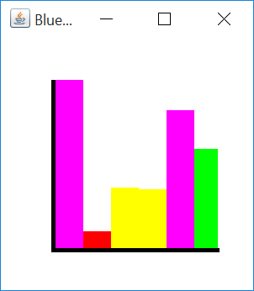

I tested the bar chart with a range of values to ensure that the bars changed colour according to the specification. After seeing the size of the bars on the canvas, I made the decision to double all the values. This is an entirely cosmetic choice and does not alter the tabled output in any way

To test that the equations for computing the module result worked I added a line of code to print out the array of computed module marks. This line of code does not appear in the final version, as all the module marks are presented as a table

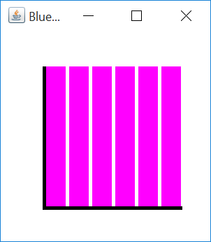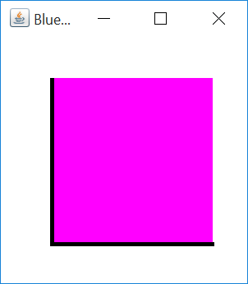

Upon further bar chart testing, I realised that multiple results of the same value could lead to ambiguous looking graphs, therefore I changed the sizes of the bars in my student chart class

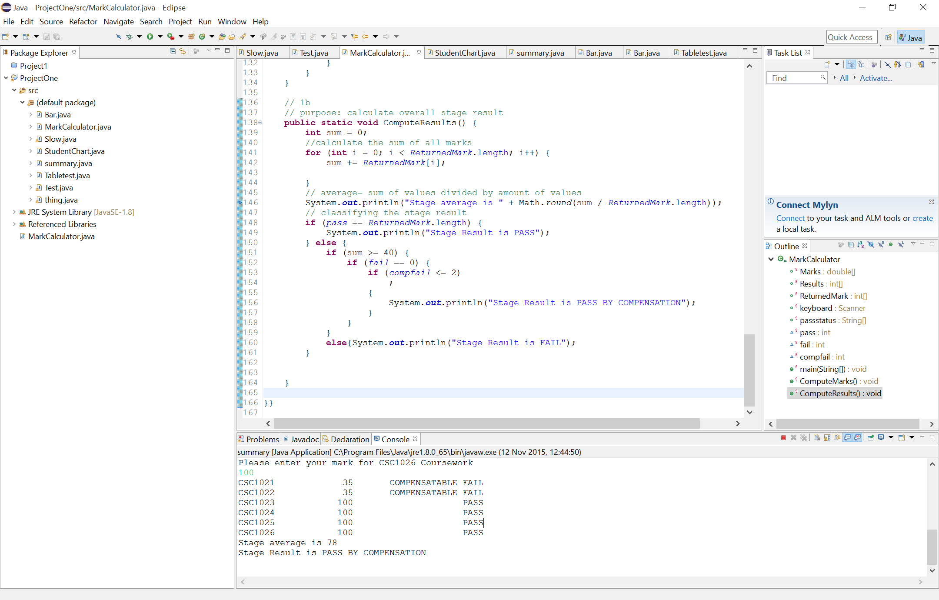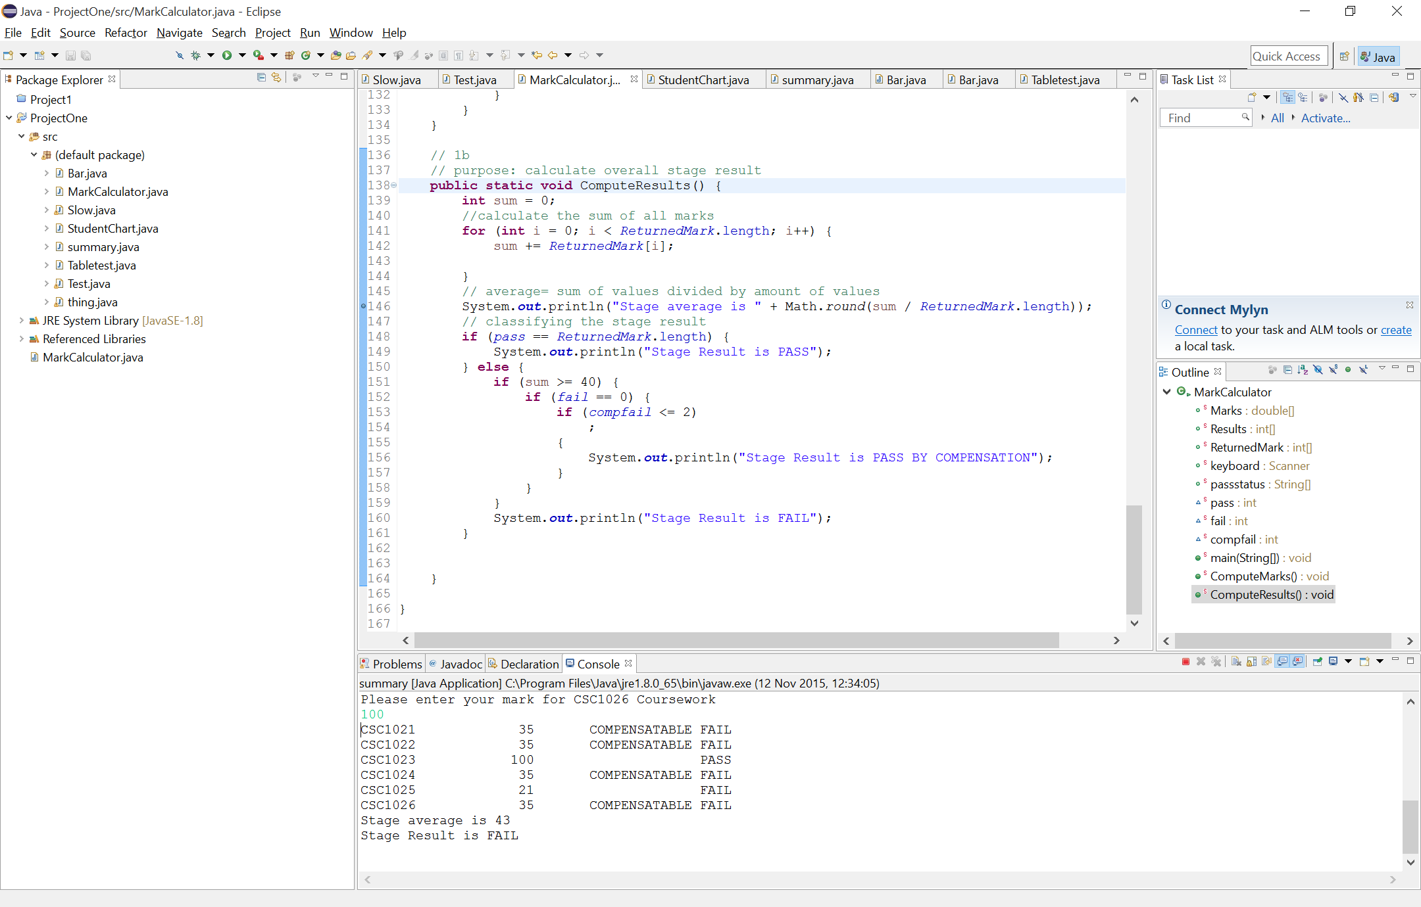

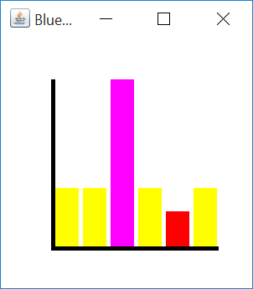

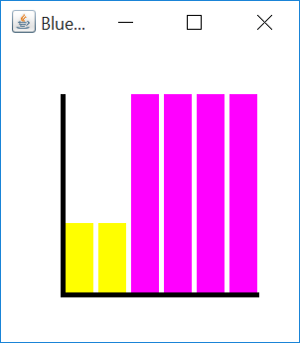

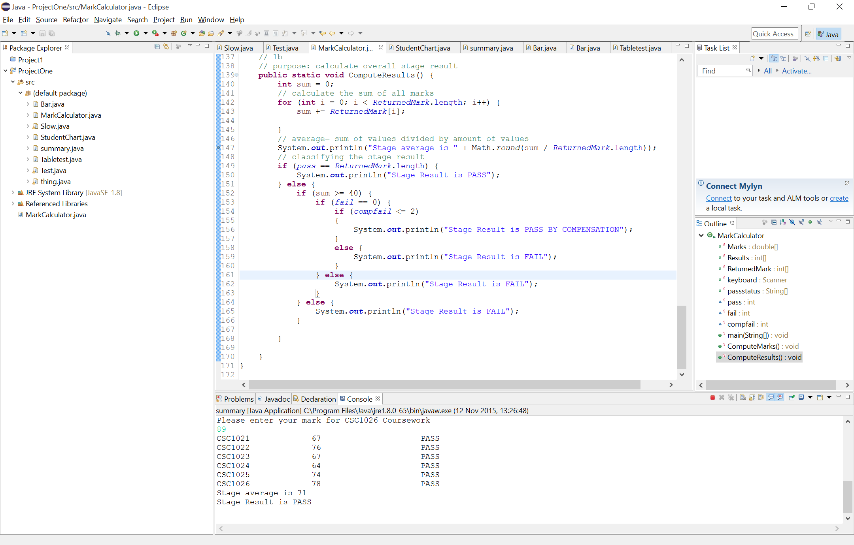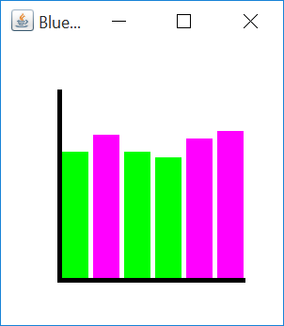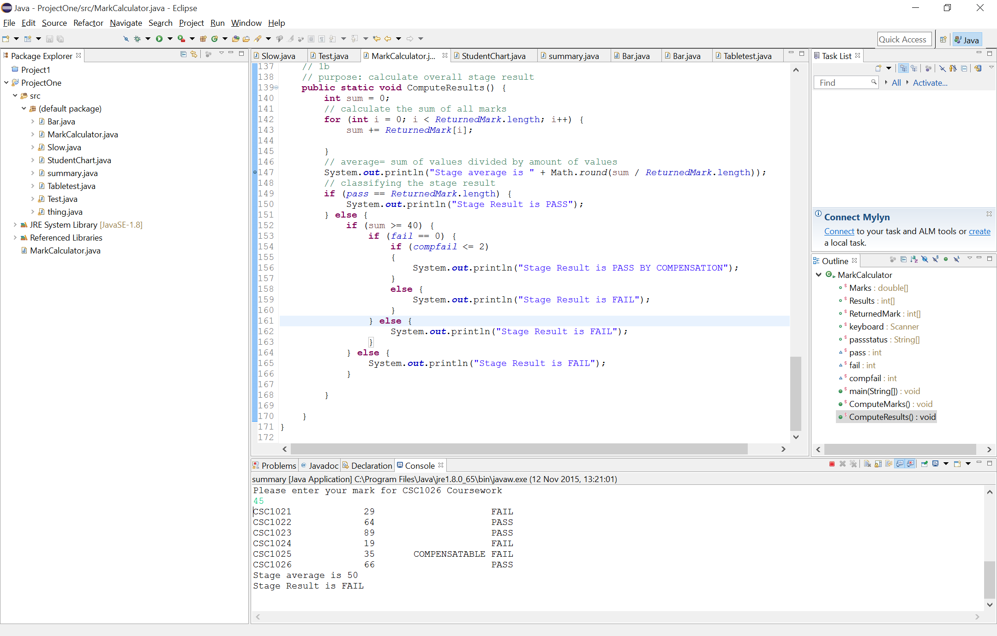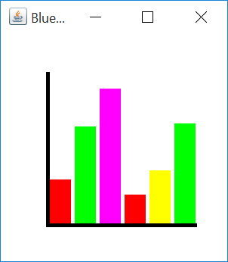

I tested my program with a wide range of values, with particular focus applied to forcing a ‘pass by compensation’ output to check if the multiple if loops worked correctly